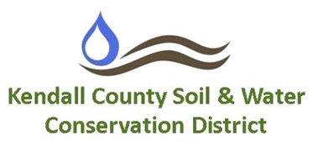

**Finance Committee Meeting**

**Monday, April 17th; 4:00pm**

**USDA Service Center, Yorkville**

4:00 pm: Call to Order

Call for Additions to the Agenda

4:02 pm: **Discussion Items**

1. Kendall County SWCD Draft FY26 Budget

5:00 pm: **Adjourn**

7775A Route 47, Yorkville, Illinois 60560 ● (630)553-5821 extension 3 [www.kendallswcd.org](http://www.kendallswcd.org)